**AN INTERACTIVE QUIZ APPLICATION**

### A MINI PROJECT REPORT

#### Submitted by

#### Group/Team No: G18/T6

**ANTERPREET KAUR, 2310991614,**

**ANUJ MAURYA, 2310991615,**

**ANUSHA JINDAL, 2310991616**

#### in partial fulfillment for the award of the degree of

## BACHELEOR OF ENGINEERING

***in***

COMPUTER SCIENCE & ENGINEERING



**CHITKARA UNIVERSITY**

**CHANDIGARH-PATIALA NATIONAL HIGHWAY**

**RAJPURA (PATIALA) PUNJAB-140401 (INDIA)**

##### DECEMBER,2023

###### ABSTRACT

In an era characterized by rapid technological advancement and evolving educational paradigms, quiz applications have emerged as powerful tools for engaging, assessing, and enhancing learning experiences. This abstract explores the multifaceted role of our quiz application i.e **QUIZZARD** in modern education, emphasizing their capacity to address traditional learning challenges and promote personalized, interactive learning journeys.

This quiz application serve as dynamic platforms that enable users to create, access, and participate in quizzes across a diverse range of subjects and topics. This application leverages various features, including user-friendly interfaces, gamification elements, and immediate feedback mechanisms, to captivate learners' attention and motivation. By encouraging active participation, this quiz application foster knowledge retention and engagement in a manner that traditional educational methods often struggle to achieve.

Furthermore, the flexibility and accessibility of this quiz application transcend geographical boundaries and socioeconomic barriers, making education more inclusive and available to a global audience. Users can embark on self-paced learning journeys, select quizzes tailored to their interests and abilities, and track their progress over time. Additionally, social sharing and collaboration features foster a sense of community and peer support among learners.

This quiz application also empower educators and content creators, offering tools for designing quizzes that cater to specific learning objectives, monitoring student performance, and refining teaching strategies based on data-driven insights. These applications facilitate the development of a diverse question bank and provide in-depth analytics, ultimately enhancing the overall quality of education.

This quiz application represents a transformative force in education. Their ability to engage, personalize, and adapt to learners' needs, as well as their capacity to empower educators, fosters a dynamic and accessible learning ecosystem. As technology continues to evolve, this quiz application are expected to play an increasingly pivotal role in shaping the future of education, making learning more engaging, accessible, and effective for people of all ages and backgrounds.

In conclusion, quiz applications are pivotal in revolutionizing the educational landscape by providing an accessible, engaging, and adaptable means of learning and assessment. Their ability to bridge the gap between traditional and modern pedagogies makes them invaluable assets in the pursuit of lifelong learning and knowledge acquisition. As technology continues to evolve, quiz applications are poised to play an increasingly integral role in shaping the future of education.

###### TABLE OF CONTENTS

|  |  |  |
| --- | --- | --- |
| Sr.no. | Section | Page no |
| 1. | Introduction | 1 |
| 2. | Problem Statement | 2 |
| 3. | TechnicalDetails | 3 |
| 4. | Key Features | 4 |
| 5. | Project Advantages | 5 |
| 6. | Result | 6 |
| 7. | Conclusion | 7 |

###### 1. INTRODUCTION

**1.1. Title:** QUIZZARD: An Interactive Quiz Application

**1.2.**  **Developers:** Anterpreet Kaur

Anuj Maurya

Anusha Jindal

**1.3. Purpose:**

This project involves creating an interactive quiz that engages users with question and multiple-choice answers. Through HTML, CSS, and JavaScript, the quiz will offer an enjoyable and educational experience. Users can test their knowledge on various topics while receiving instant feedback on their performance. It is designed to engage users in a fun and interactive way by presenting them with a series of questions on various topics or subjects. The primary purpose of this Quiz application is to:

**1.3.1.**  **Entertain and Educate:** Quiz application entertain users by challenging their knowledge and encouraging learning. They can cover a wide range of topics, from general knowledge to specific subjects like history, science & technology, cinema, travel, sports, space.

**1.4. Goals:**

The common goals of a quiz application are:

**1.4.1.** **Education and Learning:** This Quiz application aim to educate and facilitate learning by presenting users with questions and answers on a particular topic or subject matter. These quizzes can be used for self-assessment, test preparation, or as a supplementary learning tool.

**1.4,2**. **Entertainment and Engagement:** This Quiz application often serve as a source of entertainment and engagement, providing users with fun and challenging questions to test their knowledge or stimulate their curiosity.

**1.4.3.** **Gamification:** Gamification elements, such as points, badges, and leader boards, are often integrated into this quiz application to make them more engaging and competitive, encouraging users to participate and strive for high scores.

**1.4.4.** **Data Collection and Analytics:** Further, this application often collect data on user interactions, such as response patterns and demographics. This data can be valuable for understanding user behavior and improving the app's content and functionality.

**1.4.5 Feedback and Improvement*:*** Further, this application seek to gather user feedback to enhance the quality of their quizzes and user experience.

**2. PROBLEM STATEMENT**

**2.1. PROBLEM:**

Educational engagement is a pressing concern in modern learning environments. Traditional methods often lack interactivity, leading to reduced knowledge retention and learner disinterest. To address this issue, we have undertaken a project to develop an interactive quiz system. A quiz application aims to solve the problem of engaging and interactive learning and assessment by providing a convenient, accessible, and enjoyable way for individuals to test and expand their knowledge on various topics. This includes helping users to reinforce their learning, assess their understanding and potentially discover new information and interests.

**2.2. BACKGROUND:**

* Traditional exams struggle to adapt to diverse learning styles and hinder inclusivity.
* The rise of online and remote learning has exposed the limitations of conventional assessment methods.
* There's a pressing need for a dynamic quiz platform to address these challenges.
* Technology offers an opportunity to revolutionize assessments by providing instant feedback and accommodating diverse needs.
* Modern education requires assessments that can measure practical application and critical thinking.
* A sophisticated quiz platform can align with global trends, accommodating hybrid learning models.
* Insights from analytics empower educators to tailor teaching methods effectively.
* The platform can enhance student engagement through interactive and gamified experiences.
* Motivating elements, such as instant feedback and rewards, contribute to an improved learning experience.
* Ultimately, the quiz platform addresses the evolving landscape of education.

**3. TECHNICAL STATEMENT**

**3.1. VISUAL STUDIO CODE:** Visual Studio Code is a powerful and lightweight source code editor developed by Microsoft, offering robust features, a customizable interface, and a vast extension ecosystem, making it a favorite among developers for efficient coding workflows. All the code is written and debugged on visual studio code.



**3.2. HTML**: HTML is the foundational language for creating web content, using tags to structure and present information on the internet. It defines the structure of web pages, incorporating elements such as headings, paragraphs, links, and images. Hyperlinks and all other text is presented by the use of html. **In The foundation of our project, it is used for structuring and organizing the quiz content.**

** 3.3. CSS (Cascading Style Sheets):** CSS is a styling language that complements HTML by controlling the layout and presentation of web pages. It allows developers to define styles, such as colors, fonts, and spacing, to enhance the visual appeal and responsiveness of websites. The designing and styling of the website is done by CSS. Animations

are also the part of CSS. It is used for designing an intuitive and

visually appealing user interface, ensuring a seamless user experience.

**It has been used for designing an intuitive and visually appealing user interface, ensuring a seamless user experience.**

**3.4. JAVASCRIPT:** JavaScript is a versatile programming language that enables dynamic and interactive web development. Executed on the client side, it enhances user interfaces, facilitates asynchronous operations, and enables the creation of feature-rich, responsive web applications. The calculations and data selection part of website is done through java. **It has been used Java to add interactivity and functionality to the quiz, such as real-time scoring, timer functionality and dynamic feedback.**

**4. KEY FEATURES**

**4.1. INTERACTIVE QUESTIONING :**

* Engage users with interactive questions that require active participation.

**4.2. MULTIPLE TYPE QUESTIONS:**

* Provide various question formats, including multiple-choice, true/false, and fill-in-the-blank, to cater to different learning styles.

**4.3. INSTANT FEEDBACK:**

* Offer immediate feedback for each question to reinforce learning and correct misconceptions.

**4.4. SCORING AND PROGRESS TRACKING *:***

* Implement scoring mechanisms to track user progress and motivate continued participation.
* Progress dashboards for users to monitor their performance over time.
* Statistics and analytics to show areas of strength and weakness.

**4.5. TIMER FUNCTIONALITY:**

* Include optional timers to enhance user engagement and simulate time-bound scenarios.

**4.6. GAMIFICATION ELEMENTS:**

* Leader boards to showcase top scores and encourage completion.
* Badges, rewards, or achievements for completing quizzes or reaching milestones.
* Points or scoring system to track user progress.

**4.7. MOBILE RESPONSIVENESS:**

* Support for mobile devices to allow users to take quizzes on smart phones and tablets.

4.8. **USER CENTERED DESIGN:**

* We follow a user-centered design approach to ensure the quiz is intuitive and engaging for our target audience.

**5. PROJECT ADVANTAGES**

This quiz application offers a wide range of advantages for both learners and educators. Some advantages of using quiz applications are:

**5.1. Engagement and Motivation:**

This quiz application incorporates gamification elements such as leader boards, badges, and rewards, making learning more engaging and motivating. Learners are more likely to stay focused and complete quizzes when they are fun and interactive.

**5.2. Active Learning:**

Quizzes require users to actively participate by answering questions, promoting active learning. This hands-on approach aids in knowledge retention and a deeper understanding of the material compared to passive learning methods.

**5.3. Immediate Feedback:**

This quiz application provide immediate feedback on each question, letting learners know whether their answers are correct or incorrect. This instant feedback facilitates learning by helping users understand their mistakes and reinforcing correct responses.

**5.4. Personalized Learning:**

Thisquiz application uses algorithms to tailor quizzes to individual learners. They adapt the difficulty level based on user performance, ensuring an appropriate level of challenge and a personalized learning experience.

**5.5. Progress Tracking:**

Users can track their progress and see how they're improving over time. This feature motivates learners to set and achieve their learning goals.

**5.6. Accessibility:**

This quiz application is accessible to a broad audience, breaking down geographical and socioeconomic barriers. People from various backgrounds can access educational content, promoting inclusivity.

**5.7. Educator Empowerment:**

Educators benefit from this quiz application as they can create quizzes aligned with specific learning objectives, track student performance, and gain insights into learning patterns through analytics. This data-driven approach informs instructional strategies.

**5.8. Efficiency:**

This quiz application saves time for both educators and learners. They provide a structured way to assess knowledge and skills, reducing the need for manual grading and offering learners the flexibility to study at their own pace.

**6. RESULT**

**6.1. HOME PAGE:**

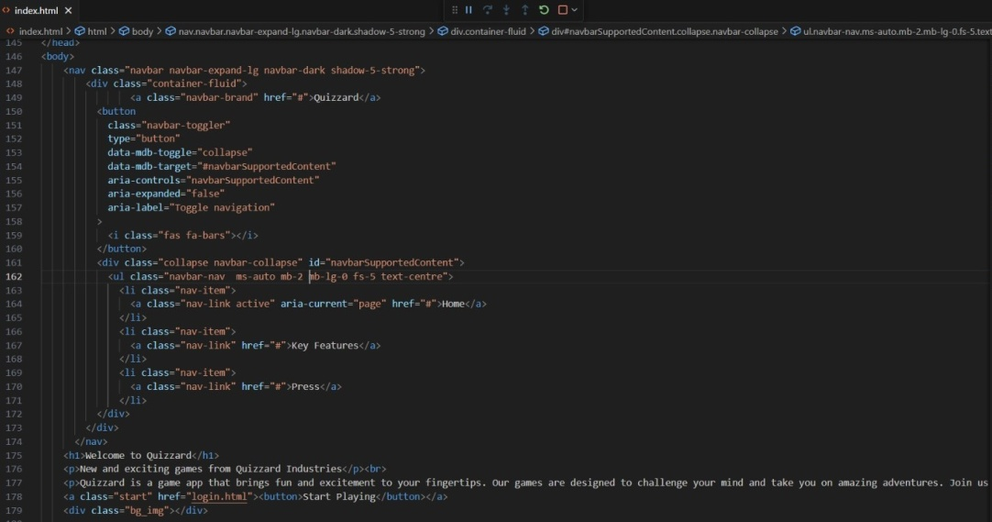

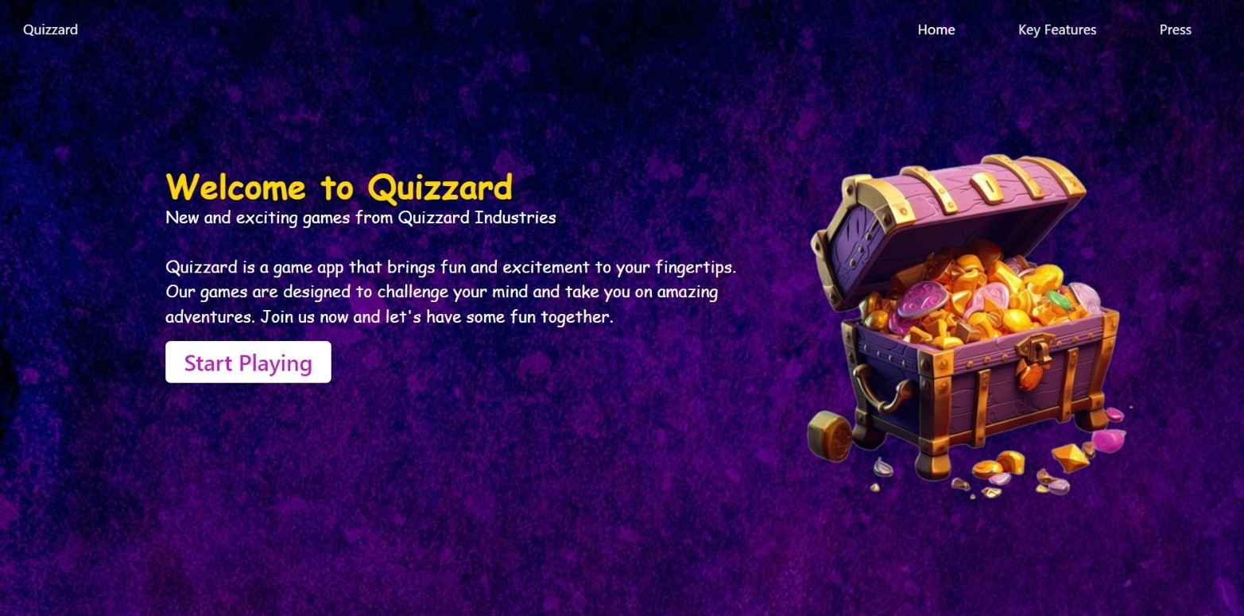

**6.2. LOGIN PAGE:**

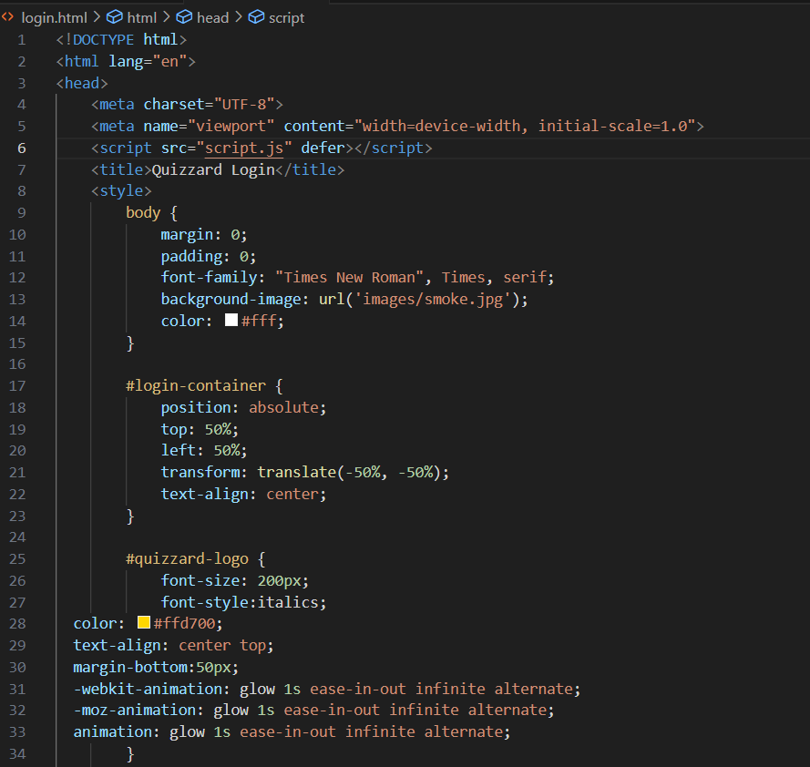

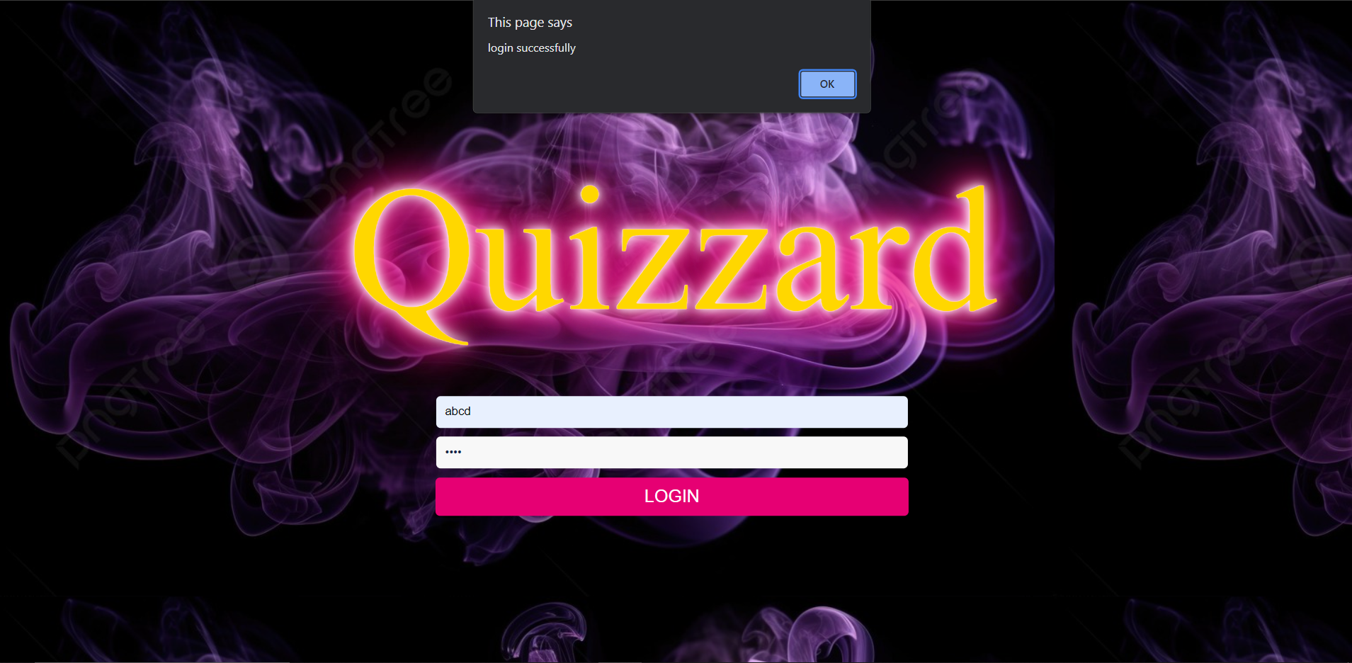

**6.3. MAIN PAGE:**

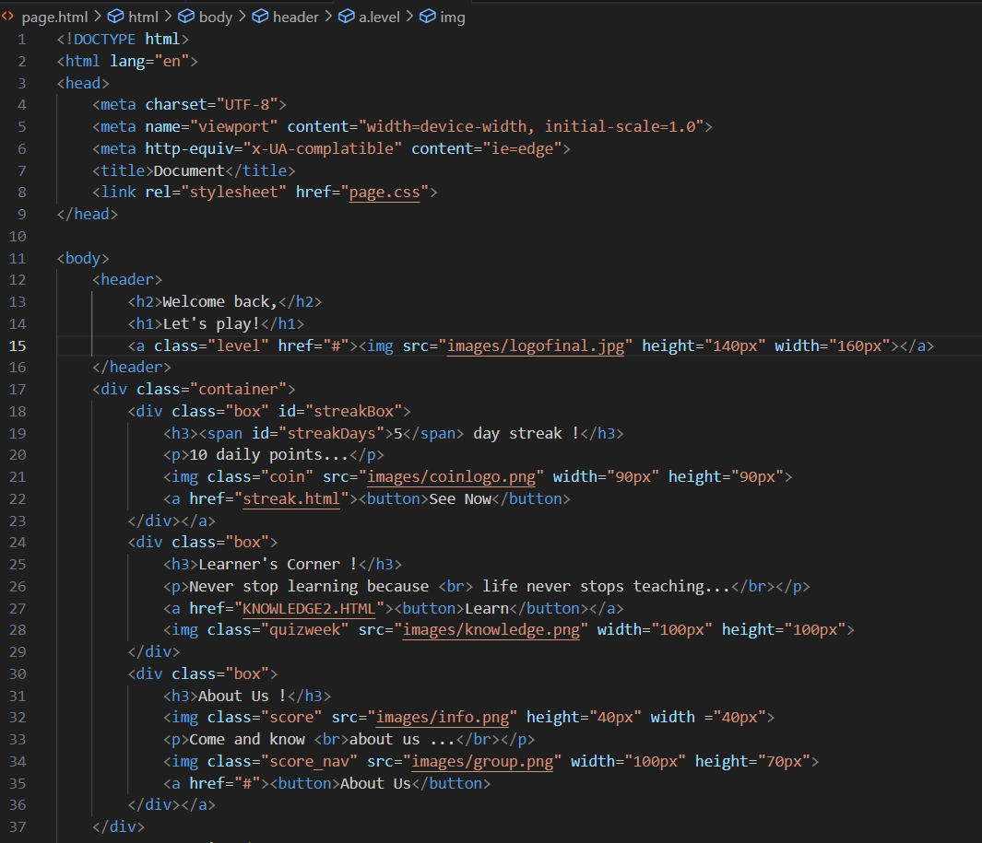

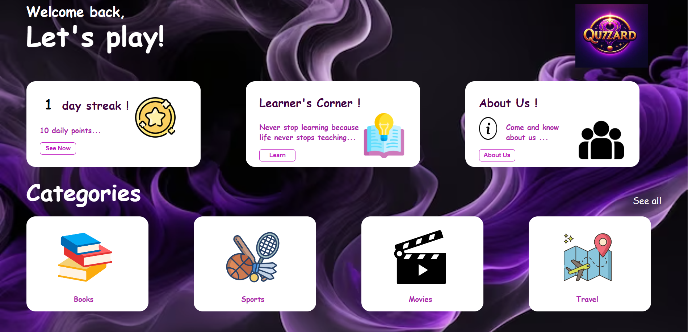

**6.3.1. STREAK :**

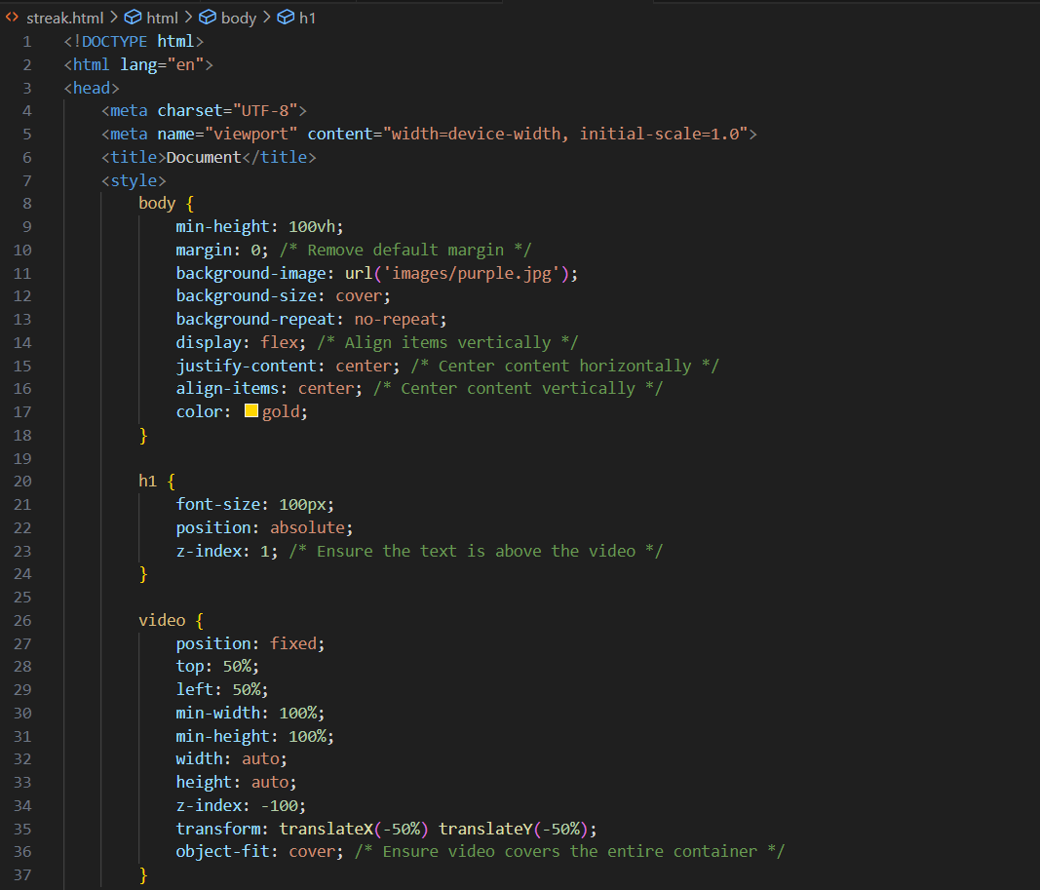



**6.3.2. LEARNER’S CORNER:**

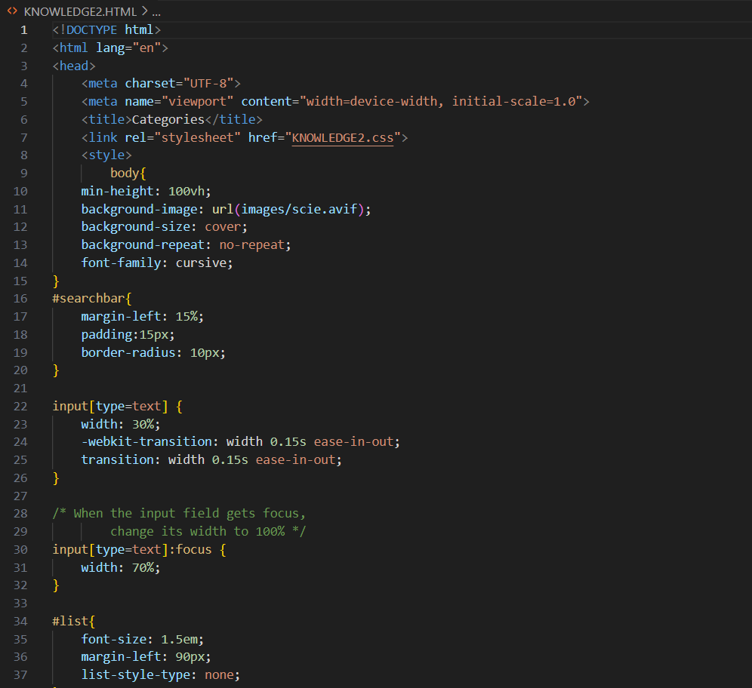

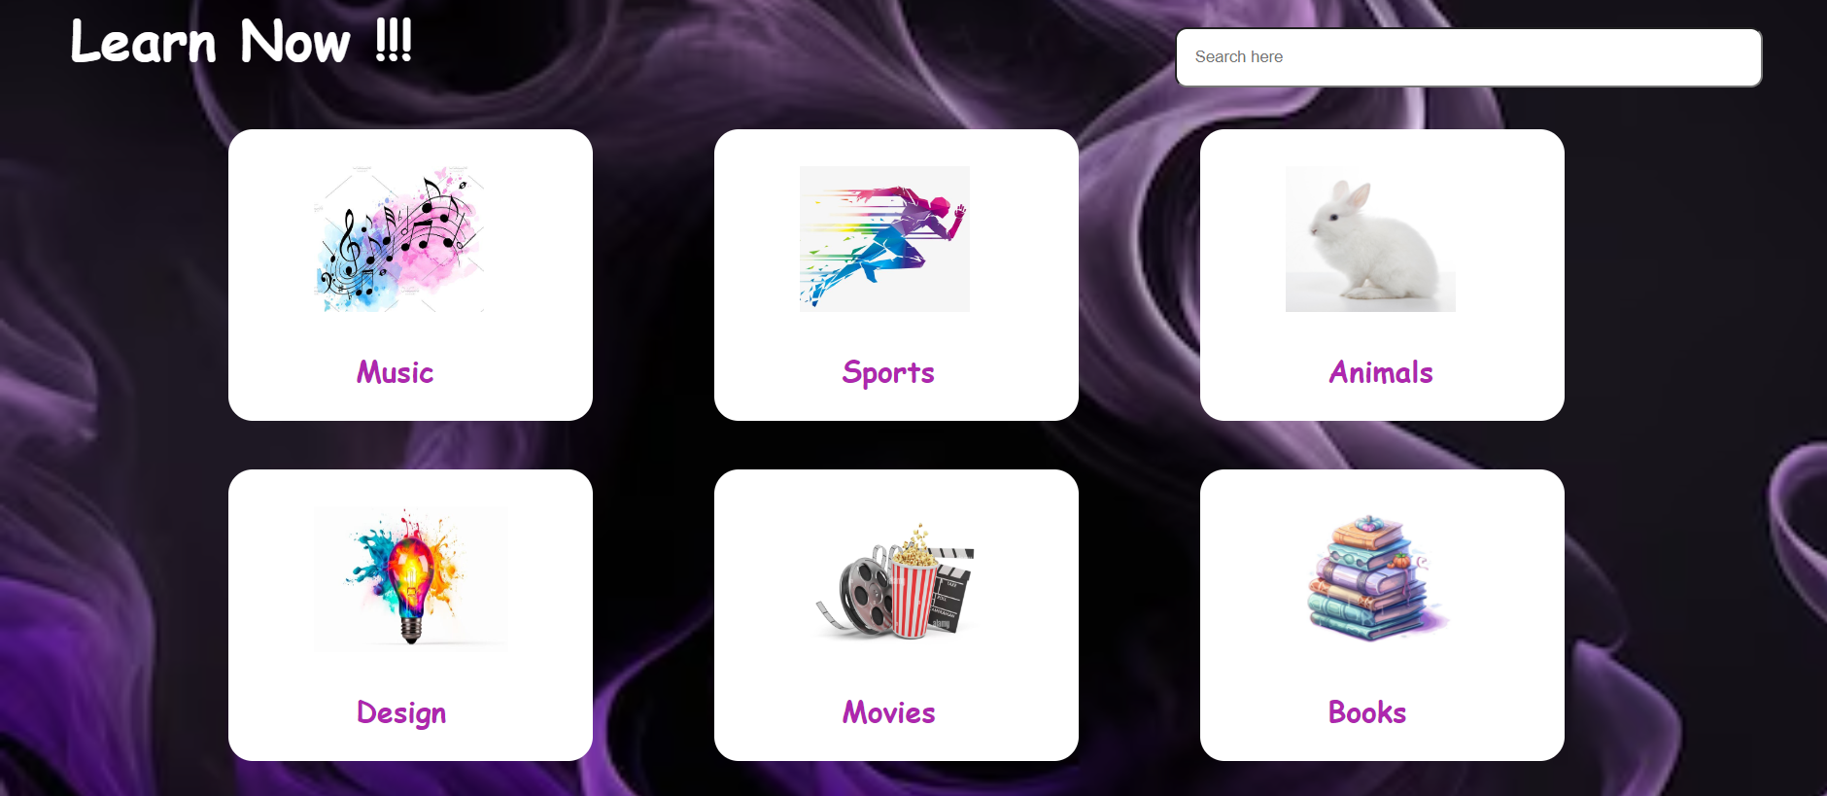

**6.3.3. CATEGORIES:**



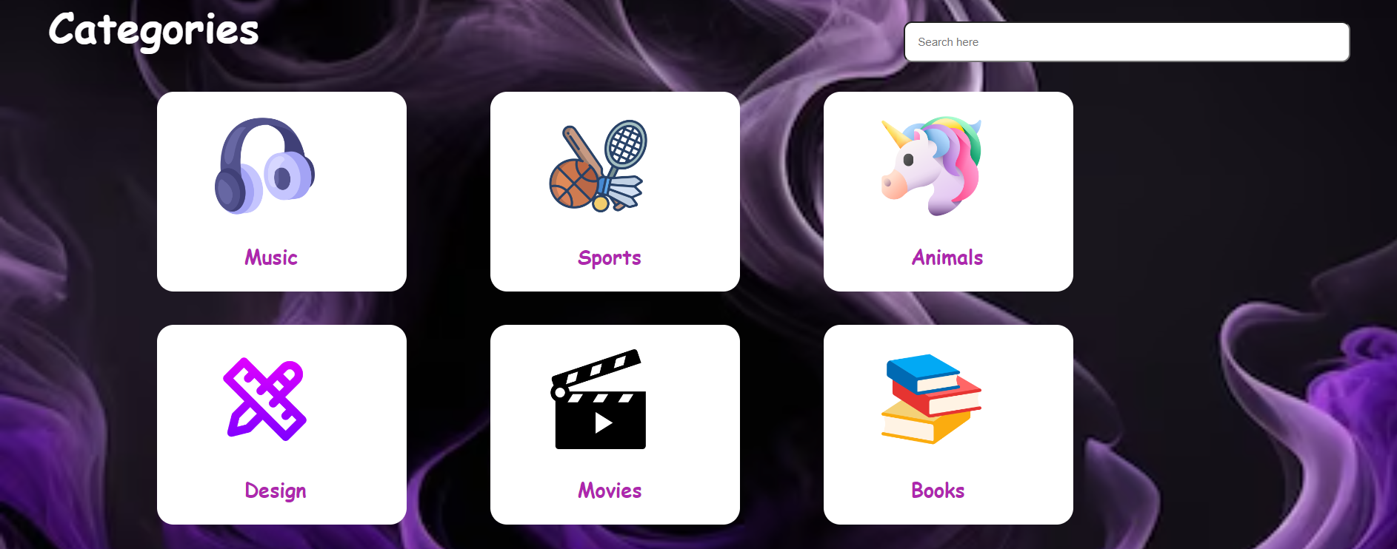

**6.4. QUESTIONS;**

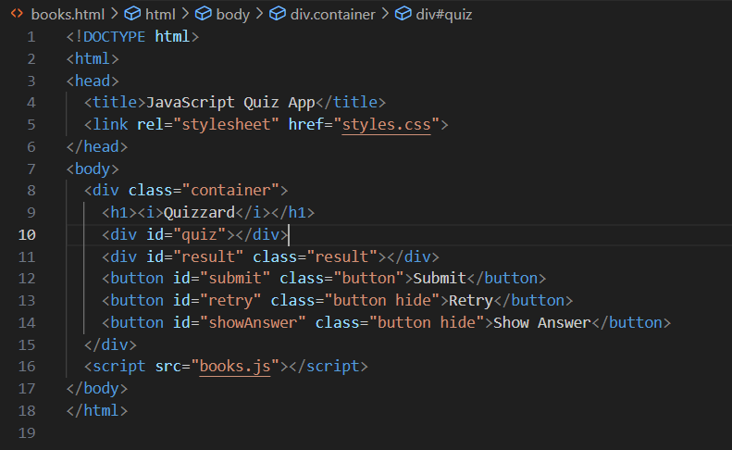

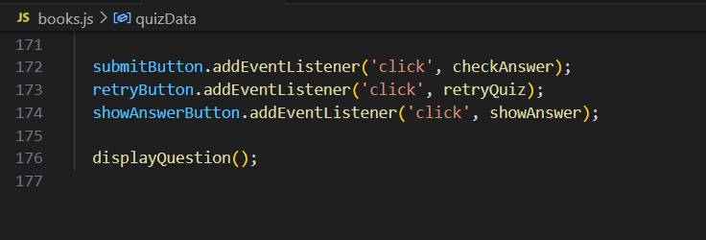



**7. CONCLUSION AND FUTURE SCOPE**

**7.1. PROJECT SUMMARY :**

* **Objective:** Our project aimed to enhance educational engagement by developing an interactive quiz platform.
* **Technologies:** We utilized HTML, CSS, and JavaScript to create an interactive and user-friendly quiz experience.
* **Key Features:** Our quiz offers interactivity, multiple question types, instant feedback, scoring, customization, and accessibility.
* **Results:** The project successfully addresses the engagement problem and fosters active learning through quizzes.

**7.2. MAIN TAKE AWAYS:**

**7.2.1. Engagement Matters:** Interactive elements significantly improve user engagement and knowledge retention.

**7.2.2. Continuous Improvement:** Agile development allowed us to adapt and enhance the quiz based on user feedback and evolving needs.

**7.2.3. Accessibility is Key:** Prioritizing accessibility ensures inclusivity and widens the reach of our educational tool.

**7.2.4. Data-Driven Insights:** Collecting user data provided valuable insights for future enhancements and customization.

**7.2.5. Team Collaboration:** Effective collaboration among team members was crucial for project success.

In summary, this quiz application enhances the learning experience by making it more engaging, interactive, and personalized. They provide a valuable tool for educators to assess and improve their teaching methods while offering learners the opportunity to acquire knowledge and skills efficiently and effectively.

**LIST OF REFERENCES**

* CANVA
* EDX
* EDMUNDS
* ESPN
* GOOGLE
* HISTORY
* IMDB
* SPORCLE
* SPOTIFY
* W3SCHOOLS
* WIKIPEDIA

**THANK YOU**